Stop guessing get a Personalized Keto Meal Plan with 5 FREE features

Quiz link

Video

I already shared the video in the chat, that’s why I’m not uploading it here.
The pixels get ruined, and even the image quality drops when downloaded from here.

Personalized Monthly Keto Plan for Weight Loss

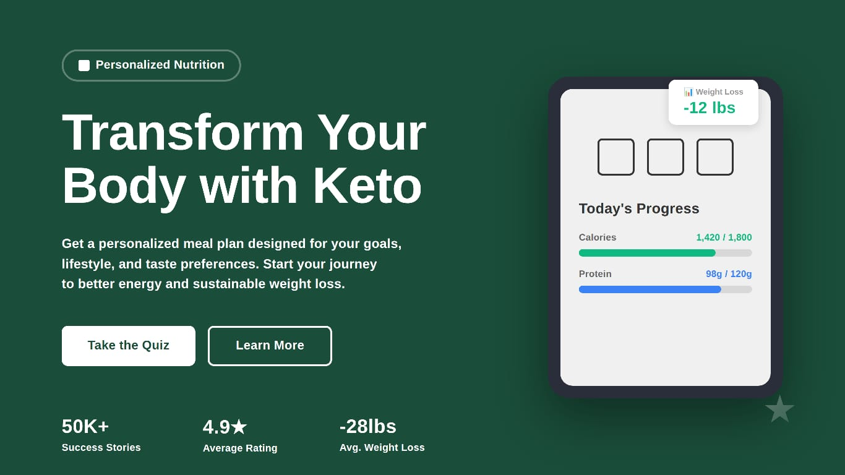

Starting a weight loss journey can be tough, but with the right help, it's doable and lasting. The Custom Keto Diet Meal Plan gives you a plan made just for you. It fits your needs and likes.

Why Personalization Matters in Keto Dieting
Personalization is crucial for diet success, especially with the keto diet. A custom keto plan considers your nutritional needs and goals. It makes the diet effective and easy to stick to.
Personalizing your keto plan can:
- Make sticking to the diet easier
- Improve nutritional balance
- Help you lose and keep off weight

What Is a Custom Keto Diet Meal Plan
A custom keto diet meal plan is made just for you. It helps you get into ketosis by focusing on what you need and like. This way, you can stick to it and enjoy it.
To make a custom keto diet meal plan, we look at your health, what you like to eat, and your lifestyle. We use this info to create a meal plan that helps you get into ketosis. It also makes sure you get all the nutrients you need and that you're happy with your food choices.

How the Personalization Process Works?

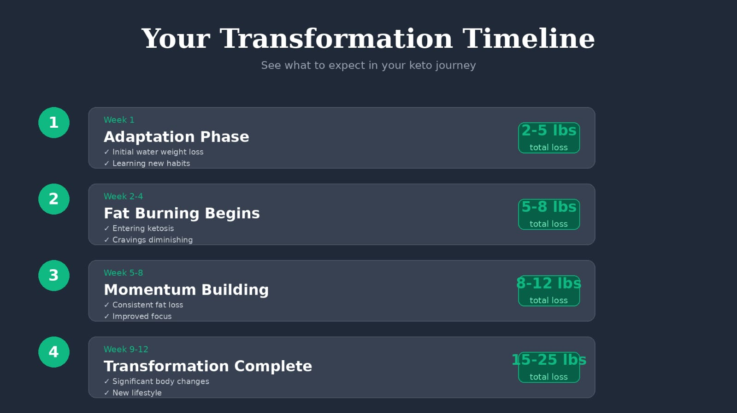

First, we ask you a lot of questions. We want to know about your health goals, food likes, and how you live your life. This helps us figure out the best diet plan for you.
We look at your weight, how active you are, and any food rules you have. Then, we create a meal plan just for you. It's designed to help you do well on the keto diet.

The Difference Between Generic and Custom Keto Plans
Generic keto plans are the same for everyone. They might not work as well for people with special needs or tastes. Custom keto plans, on the other hand, are made just for you. They offer a better way to get into and stay in ketosis.
Features | Generic Keto Plans | Custom Keto Plans
Personalization | Limited | Highly Personalized
Dietary Flexibility | Restricted | Flexible and Adaptable
Nutritional Balance | General Recommendations | Tailored Nutritional Balance
Effectiveness | Variable | Optimized for Individual Success
Choosing a custom keto diet meal plan means you get a diet that really works for you. It's a great way to lose weight and improve your health.

Key Takeaways
- A personalized approach to weight loss through a tailored keto plan.
- Includes a meal plan, food selection report, and shopping list for ease.
- Simplifies the keto diet process with calorie estimates and food combination guidance.
- Highlights common keto mistakes to avoid for better results.
- Designed for individuals seeking a structured weight loss journey.
- Supports healthy and sustainable weight loss.

